Title of the work
Full first and second name of Author1^{1,2}, full first and second name of Author2³
¹ Affiliation of Author1 (name and postal address)
² Affiliation of Author1 (name and postal address)
³ Affiliation of Author2 (name and postal address)
E-mails: (e-mails of all authors, in order)
Keywords: keyword_1, keyword_2 (up to five)

General
This document contains instructions for Authors who wish to submit a two-page extended abstract for KomPlasTech & NeuroMet 2027, to be held in Krakow, Poland, on April 5–7, 2027. Please read this document carefully before typing your abstract.
Just as you do, we want the conference proceedings to remain a valuable reference for a long time. This means that all contributors should do their best to write very good abstracts: well organised, concise and clear, with carefully chosen words and terms, so that they mean exactly what the authors want to express. Standard grammar, punctuation and abbreviations should be used throughout.

Manuscript format
All manuscripts should be typed on portrait-oriented DIN A-4 sheets (210 × 297 mm) with a constant 25 mm margin on every side (top, bottom, left and right). Times New Roman should be used throughout the document.
The document is style-driven. Apply the Abstract Title style to the title (14 pt, bold, upper-case), Authors to the author list (9 pt) and Affiliation to the affiliations (8 pt, italic). These sit at the top margin with single spacing.
Type the running text with the Body Text style: justified, single column, single-spaced 9 pt, with a first-line indent on every new paragraph. Section titles use the Heading 1 style (11 pt, bold) and are numbered automatically; use Heading 2 for sub-headings (9 pt, bold).

Figures, tables
Figures and tables should be placed within the text, as close as possible to their first mention, and should not exceed the column width.
Figures and tables are numbered with Arabic numerals in order of appearance, with clear captions (Caption style) placed below figures and above tables. Example: results are presented in Figure 1 and in Table 1.
Table 1. Four-pass plane-strain compression schedule.
Pass | Temperature (°C) | Strain, ε (–) | Inter-pass time (s)
1 | 1100 | 0.30 | 10
2 | 1050 | 0.30 | 5
3 | 1000 | 0.25 | 3
4 | 950 | 0.25 | –
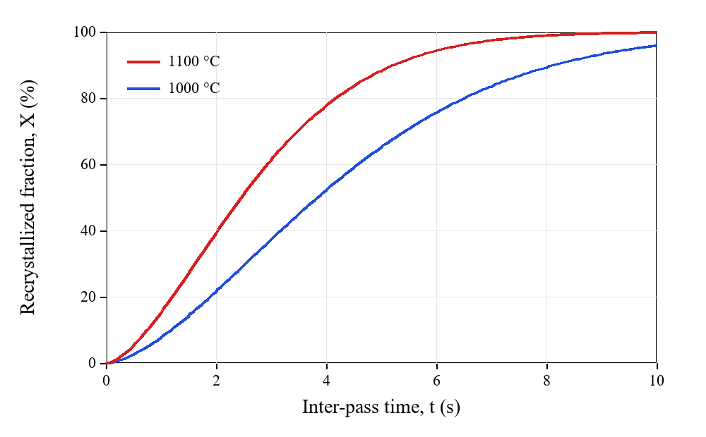
Figure 1. Recrystallized fraction X(t) versus inter-pass time at 1000 °C and 1100 °C.

Equations
MathType or OMML (Office Math Markup Language) may be used. Please do not insert equations as images. All equations are numbered, and every new symbol is listed and defined immediately after the equation, as follows:
$X(t) = 1 - exp(-k·t^{n})$ (1)
where: X – recrystallized fraction, k, n – coefficients, t – time. Numerical data must be expressed in S.I. units for homogeneity and clarity.

References
Reference numbers in the text appear in square brackets [1] and are placed immediately after the final word of the sentence in which they are mentioned, before the punctuation mark.
Each abstract contains a single-spaced list of the most important references, numbered consecutively in order of appearance. There are essentially five entry types, formatted as follows:
- Articles: author(s), article title, publication title, volume, year, inclusive pages.
- Books: author(s), chapter title, book title, publisher, city or country, date, inclusive pages.
- Proceedings: author(s), contribution title, conference title, editors, city, date, inclusive pages.
- Web pages: address, date.
- Unpublished works: author(s), title, name of event, city and country, date.

Examples of references
- Beynon J.H., Sellars C.M., Modelling microstructure and its effects during multipass hot rolling, ISIJ International, 32, 1992, 359–367.
- Kobayashi S., Oh S.I., Altan T., Metal forming and the finite element method, Oxford University Press, New York, Oxford, 1989.
- Mori K., Osakada K., Finite-element simulation of three-dimensional deformation in shape rolling, Proc. NUMIFORM’89, eds. Thompson E.G., Wood R.D., Zienkiewicz O.C., Samuelsson A., Fort Collins, 1989, 337–342.
- Roucoules C., Dynamic and metadynamic recrystallization in HSLA steels, PhD Thesis, McGill University, Montreal, 1992.
Acknowledgements. If present, the acknowledgements section should be informative yet as concise as possible.

